E-Crime eXchange
Version 2.1
Functional Specification
Version: 0.1

Prepared by:
Revision Chart
This chart contains a history of this document’s revisions. The entries below are provided solely for illustration purposes. Those entries should be deleted until the revision/s they refer to have actually been created.
The document itself should be stored in revision control, and a brief description of each version should be entered in the Revision Control System. A brief description can be repeated in this section. Revisions need not be described elsewhere in the document, unless they explain the document.

Version | Primary Author(s) | Description of Version | Date Completed
Draft | TBD | Initial draft created for distribution and review comments | (To be decided) TBD
Preliminary | TBD | Second draft incorporating initial review comments, distributed for final review | TBD
Final | TBD | First complete draft, which is placed under change control | TBD
Revision 1 | TBD | Revised draft, revised according to the change control process and maintained under change control | TBD
Revision 2 | TBD | Revised draft, revised according to the change control process and maintained under change control | TBD
Etc. | TBD | TBD | TBD

PrefaceThe preface contains an introduction to the document. It is optional and can be deleted if desired.
Contents
New paragraphs formatted as Heading 1, Heading 2, and Heading 3 will be added to the table automatically. To update this table of contents in Microsoft Word, put the cursor anywhere in the table and press F9. If you want the table to be easy to maintain, do not change it manually.
1. Introduction 6
1.1 Project Overview 6
1.2 Problem Statement 6
1.3 Customer 6
1.4 Affected Groups 6
1.5 Assumptions 6
1.6 Dependencies/ External Systems 7
1.7 Definitions and Acronyms 7
1.8 Reference/ Source Documents 7
1.9 Goals 7
2. System Functions/ Functional Requirements 8
3. System Architecture 10
3.1 System Architecture Diagram 10
4. Use Case Model 11
4.1 List of Actors 11
4.2 List of Use Cases 11
4.3 Use Case Diagram 12
4.4 Use Case Buy Item 13
4.5 System Sequence Diagrams 14
4.6 User Interface 15
4.7 Data Dictionary 15
5. Conceptual Model 16
6. Glossary 17
7. Index 18
8. Appendices 19

List of Figures
New figures that are given captions using the Caption paragraph style will be added to the table automatically. To update this table of contents in Microsoft Word, put the cursor anywhere in the table and press F9. If you want the table to be easy to maintain, do not change it manually.
This section can be deleted if the document contains no figures or if otherwise desired.
Figure 1 System Architecture 10
Figure 2 System Level Use Case Diagram 12
Figure 3 Conceptual Model 16

Introduction

Project Overview
The e-Crime eXchange (eCX) is a Graphical User interface and API that allows users to insert, list, or modify data records related to fraud or malicious activities. The GUI component also includes an administrative interface to manage member companies and their users.
The APWG originally accepted phishing URLs from members and shared a combined csv file with those that submitted data. Once that file became large, the file was hosted on an FTP server for easier access. As more Phishing URLs started coming in the FTP server would generate a new ‘file’ every five minutes and members could retrieve the file when they wished. Soon it took longer than five minutes to generate the new file so a real transactional server was envisioned.

The first cut of the transactional eCrime eXchange (eCX) used a bored developer from one of our members. He decided to use PHP and the CakePHP framework. It made sense as this was 2008. A few years later that developer moved on and we used another person. The completed version, maybe called eCX0.5, used PHP5 and a MySQL database to keep the URLs. A new function that allows members to create and control their own ‘groups’ was added.

A few years on, a different developer arrived to deal with the server becoming overwhelmed. He added a sphinx full-text search database to help speed up text searches and added a new GUI front-end and divided the eCX application into ‘GUI’ and an ‘API’ portions.

We added new modules to allow members to share malicious IP Addresses, malicious domains, and a copy of phishing lures sent to us (report_phishing).

A few years after this work, the database had grown where neither MySQL nor sphinx could handle the number of requests per second hitting the server. Work began on using an elasticsearch database instead of MySQL and sphinx. The new code was written in PHP7 and had to co-exist with the older PHP5 codebase. Unfortunate, the old database calls and process were not removed so an “insert” into elasticsearch also performs operations on MySQL and sphinx.

Along the way, the groups functionality was deemphasized and a new feed colleting cryptocurrency identifiers used in crime was added.

In 2021, the current developer left and we re-examined the eCX system design. A project (eCX2) was started to remove the sphinx database as the sphinx project was abandoned in 2018. (In 2020 it was brought back to life by the original author.) The sphinx database was the basis for the no longer used ‘group’ functionality and could be retired. Unfortunately, the ecx2 project was beset by other influences such as making the GUI more 2020 and sphinx is still being used; alongside MySQL and elasticsearch. And PHP5.

code base.

Problem Statement
This project is an attempt to remove the old technology, called eCX2.1. The goal was to move eCX1 to the latest version of CakePHP and incorporate the eCX2 functionality into one codebase.

Assumptions
Things we assume in this project:
- eCX1 and eCX2 will need to operate concurrently with ecx2.1 development.
- The development and deployment will occur “in the cloud”.
- We will continue to use the CakePHP framework.

Dependencies/ External Systems
Systems and/ or products, this project depends upon for its completion.
- An elasticSearch database for storing and accessing data records.
- A MySQL database to store company and user information.

Definitions and Acronyms
The following terms are used in this document.
- Member – An organization, like a company, that has met the membership requirements,
- User – A member’s employee that uses the eCX in some way.
- Data record – A set of data items describing an e-crime event.
- Data feed – A structured grouping of data records.
- Module – The software that implements an eCX data feed. Modules are controlled by the APWG.
- Module Endpoint – The web-exposed address of a module, e.g., /phish, /crypto.
- Group – A collection of data and/or documents controlled by a user.

Reference/ Source Documents
Provide references to all documents that have been consulted during the analysis phase.

Goals
This project has modest, but important goals:
- Remove the no-longer used software components.
- Upgrade PHP and the CakePHP framework to the current version.
- Don’t remove any current functionality.

System Functions/ Functional Requirements
This section is can be skipped, if Requirement Specifications document has been developed for the project. Otherwise this section is mandatory.
This section may contain
- end user, operator, support, or integration functions,
- performance requirements,
- design constraints,
- programming language, and
- interface requirements.
System functions are descriptions of what a system is supposed to do. They should be identified and listed in logical cohesive groups, with their category (priority) assigned. These system functions will be identified as a result of the requirement gathering process conducted with the client. However, in some cases, prior to the development of the Functional Specifications the requirements may already have been listed in a document: if this is so then a reference to the document may suffice.
To verify that some X is indeed a system function; it should make sense in the following sentence:
The system should do <X>
The table below gives an example of how system functions can be listed:
- The Functions column gives a brief one-line description of the required functionality.
- The Category column refers to the status of the functionality for the proposed system. The options for the Category are defined below.
- The Attribute column defines the system characteristics. The Details and Constraints column specifies the conditions within which the attribute is applicable. Section 1.12 defines the default Attributes and the related Constraints. In case, the default conditions are to be over-ridden then the conditions can be defined in this table.
Function Categories
Function Category | Meaning
Evident | Should perform, and user should be cognizant that it is performed.
Hidden | Should perform, but not be visible to users. This is true of many underlying technical services, such as save information in a persistent storage mechanism. Hidden functions are often missed during the requirements gathering process.
Frill | Optional; adding it does not significantly affect cost or other functions.

Ref # | Functions | Category | Attribute | Details & Boundary Constraints
R1.1 | Record the underway sale – the items purchased | Evident | System Response time | Price listing within 3 seconds  Availability agreement in less than 10 sec
R1.2 | Reduce inventory quantities when a sale is committed | Hidden | Concurrent user load
… | … | …
System Attributes/ Nonfunctional Requirements
System attributes are nonfunctional system qualities – such as ease of use. System attributes are characteristics of the system; they are not functions.
System attributes have a possible set of Attribute Details, which tend to be discrete, fuzzy, symbolic values of the attribute, such as:
response time = psychologically appropriate
interface metaphor = graphical, browser-based
Some system attributes may also have Attribute Boundary Constraints, which are mandatory boundary conditions, usually on a numeric range of values of an attribute, such as:
response time = five seconds maximum
In this section the Category column indicates whether or not the attribute is critical for the operation of the system.
The Category can take two options:
- Optional
- Mandatory
Attribute | Details and Boundary Constraints | Category
Response time | (Boundary constraint) When recording a sold item, the description and price will appear within 5 seconds | Optional
Concurrent User Load | A minimum of 10 users connected simultaneously | Mandatory

System Architecture
Describe the system architecture, or simply provide the architecture diagram. For School system it may include web based front end, webserve , database etc. Don’t worry too much about it just give a simple diagram of a typical web based project.

System Architecture Diagram
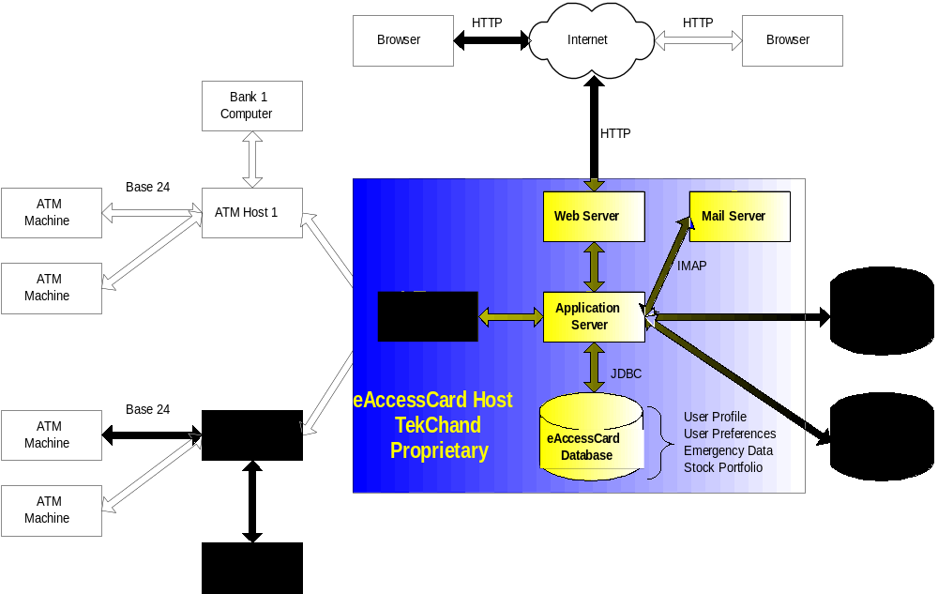
Figure 1 System Architecture

Use Case Model
Describe the following items:
- Actors & use cases
- Use case diagrams
- High level, essential use cases

List of Actors
- GUI user
- API user
- Administrator

List of Use Cases
The list of use cases in this project are listed below:

API Function Use Cases
Insert a Data Record into a data feed
Modify a data Record in a data feed
Retrieve a set of records (1->500) from a data feed

GUI functions use cases
User Login
Insert a Data Record into a data feed
Modify a data Record in a data feed
View a set of records from a data feed

GUI Administrator use cases for Company/member
Enter company (member) details
Update member details
Generate a member invoice
Process a member invoice
Invite member’s user to eCX
User requests access to a module
Admin grants access to a user
Disable user access

GUI Administrator use cases for Metrics use cases
Show members/users activity by POST, GET, and PATCH per selectable month
Show brand activity per selectable month
Show overall platform activity when user logs in

Use Case Diagram
Create the system level use case diagram

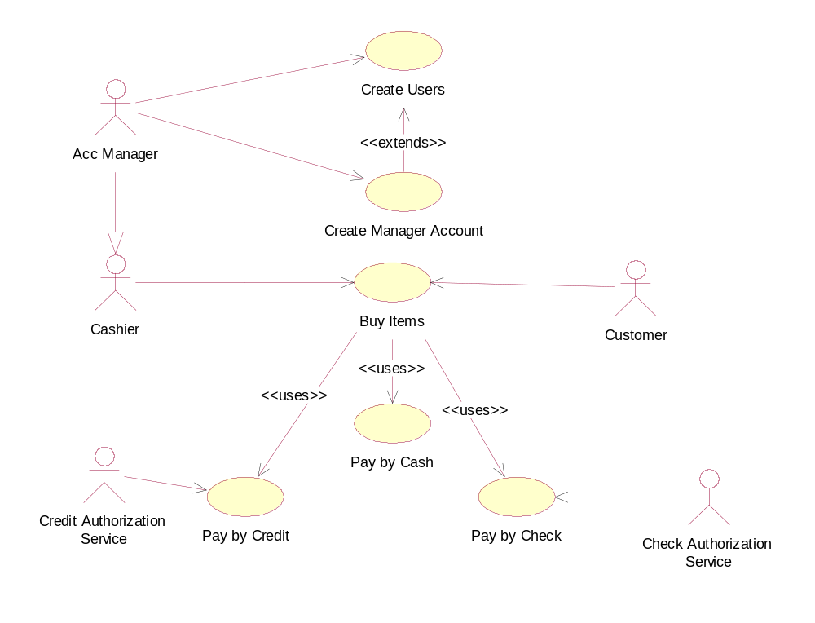
Figure 2 System Level Use Case Diagram

API Function Use Cases

Insert a Data Record into a data feed
Section: API
Actors: |  | Api User
Purpose: |  | Insert data into a data feed
Description: |  | User sends properly formatted JSON to a module endpoint.
Cross References: |  | Functions: R1.1, R1.2  Api User provides an API Key or Token for authentication
Pre-Conditions |  | User and company are active in users table  User has posting privileges to this module endpoint.
Successful Post-Conditions |  | State of the system after completion of the operation.
Failure Post-Conditions |  | State of the system after completion of the operation.
Typical Course of Events
Actor Action |  |  |  |  |  |  | System Response
1 |  |  |  |  | This use case begins when a customer arrives at the Point of Sale checkout with items to purchase.
2 | The cashier records each item
4 | … |  |  |  | 3 | Determines the item price and adds the item information to the running sales transaction.
7 | Customer selects payment type:  - If cash payment, see section Pay by Cash  If credit payment, see section Pay by Credit |  |  |  | 5 | …
 |  |  |  |  | 8 | Logs the completed sale
 |  |  |  |  | 9 | Updates inventory levels
11 | Cashier gives the receipt to the customer |  |  |  | 10 | Generates a receipt
12 | The customer leaves with the items purchased
Alternative Course
Step 2: |  |  |  | Invalid item identifier entered. Indicate error.
Step 7: |  |  |  | Customer could not pay. Cancel sales transaction
Section: Pay by Cash
Typical Course of Events
Actor Action |  |  |  | System Response
1 |  |  |  |  | The customer makes a cash payment
2 | The cashier records the cash tendered
4 | The Cashier deposits the cash received and extracts the balance owing and gives it to the customer |  |  |  | 3 | Presents the balance due back to the customer, if any.
Alternative Courses
Step 1: |  |  | Customer does not have sufficient cash, may cancel sale or initiate another payment method.
Step 4: |  |  | Cash drawer does not contain sufficient cash to pay balance.
Modify a data Record in a data feed
Retrieve a set of records (1->500) from a data feed
GUI functions use cases
User Login
Insert a Data Record into a data feed
Modify a data Record in a data feed
View a set of records from a data feed

GUI Administrator use cases
Company/member use cases
Enter company (member) details
Update member details
Generate a member invoice
Process a member invoice
Invite member’s user to eCX
User requests access to a module
Admin grants access to a user
Disable user access

Metrics use cases
Show members/users activity by POST, GET, and PATCH per selectable month
Show brand activity per selectable month
Show overall platform activity when user logs in

System Sequence Diagrams
This is an optional section. It may help when the Typical Course Of Events (Section 3.4) is too detailed to clarify the flow properly.
A system sequence diagram is a picture that shows, for a particular scenario of a use case, the events that external actors generate, their order, and intersystem events. All systems are treated as a black box; the emphasis of the diagram is events that cross the system boundary from actor to systems.
A system sequence diagram should be completed for the typical course of events of the use case, and possibly others, for the most interesting alternative courses.
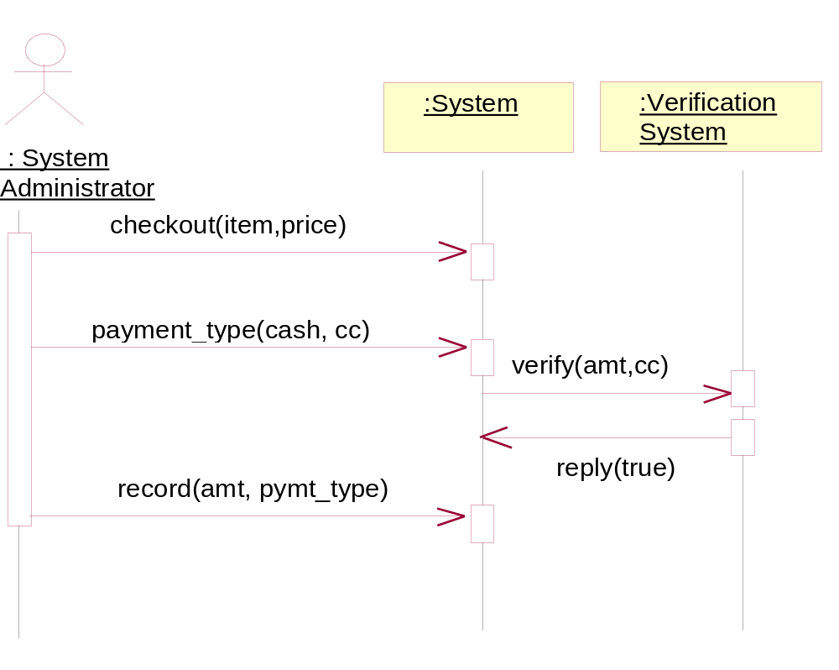

User Interface
This section may be used to provide screenshots of the application to give an idea of how the GUI will appear.

Data Dictionary
This section may be used to provide the details of interface elements that are present on the screenshots.

Element Name | Type | Validation | Mandatory | Remarks

Conceptual Model
Draw your conceptual model after writing all your use cases. This is an optional section, which will be applicable when there are a large number of entities.
A Conceptual model is a representation of concepts in a problem domain. It is illustrated with a set of static structure diagrams. It can represent the following:
- Concepts
- Associations between concepts
- Attributes of concepts
A new example consistent with the Accounting System example used in this document should be provided.
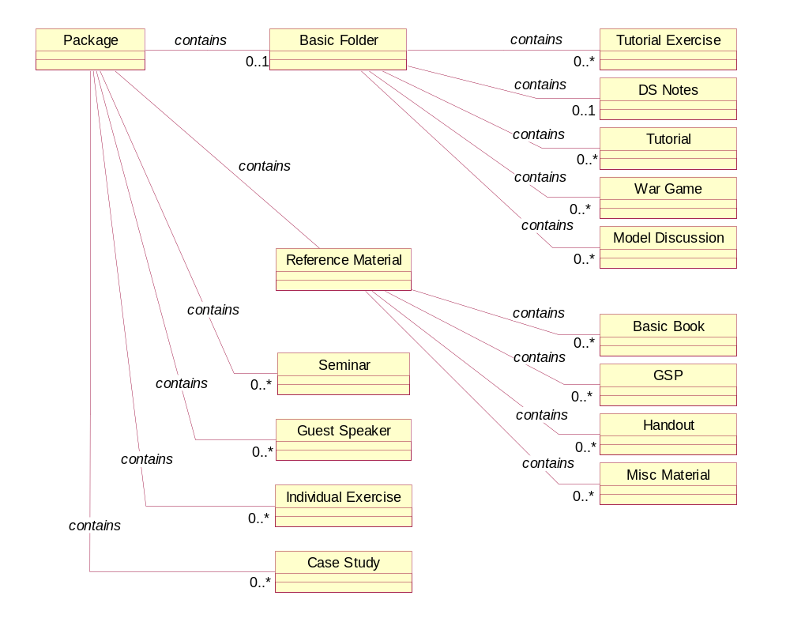
Figure 3 Conceptual Model
concept reacts differently to events depending on their state, it is considered as state-dependent concept or type. Create state diagrams only for state-dependent concepts with complex behavior.
A relevant example needs to be inserted here.

Glossary
A glossary or model dictionary lists and defines all the terms that require clarification in order to improve communication and reduce the risk of misunderstanding.
Record domain or business terms, rules, concepts, etc. in the glossary

 | Comments
DS | DS stands for Directing Staff, a class instructor
Div | Stands for a Division with fixed strength and organization
Package | ….

Index
The index is optional. If the document is made available in electronic form, readers can search for terms electronically.

Appendices
Include supporting detail that would be too distracting to include in the main body of the document.

